Title (Titel is written briefly, clearly, and informatively with Font Book Antiqua Size 14, Bold, Sentence case, Spacing 1, Align text left)

No | Name | Email
1 | First Author | First Author’s Email
2 | Second Author | Second Author’s Email
3 | Third Author | Third Author’s Email
.. | .. | ...

^{1,2} Author 1 2’s affiliation. (in case of the same affiliation)

³ Author 3’s affiliation (written in the next row if it has a different affiliation)
author@google.com (Corresponding Author)
Received day month year; revision date, accepted date
Abstract
Abstract is written with a minimum of 100 words and a maximum of 250 words. Abstract contains aim, problem statement, method, results, and conclusion. (Book Antiqua 10,5pt - 1 space - 6pt after paragraph)
Keywords: 3 – 5 words that represent the article, and separated by a semicolon (;).

- Introduction (Subtitle Book Antiqua 18)
Introduction is written in this section with font Book Antiqua Size 11 dan Spasi 1.0. Citation sytle 7th APA ex: (Skeivalas & Dargis, 2006).
- Method
Write down the research method, stages of study, and flowchart. Font Book Antiqua Size 11 dan Spasi 1.0.
- Results and Discussion
Results and discussion are written in this section and written with font Book Antiqua Size 11 and Spacing 1.0. In case this section or the previous section has a subsection, it can be written as follows:
  - Subtitle is written in bold face
This subsection is written using font Book Antiqua Size 11 dan Spasi 1.0
  - Subtitle is written in bold face
This subsection is written using font Book Antiqua Size 11 dan Spasi 1.0. Table 1 is an example of how to add a table and a table caption to the article.

Table 1. Result of laboratory test
No | Test | Result
1 | First test | 200
2 | Second test | 300
3 | Third test | 350

The following Figure 1 is an example of how to add a figure and its caption in the article.

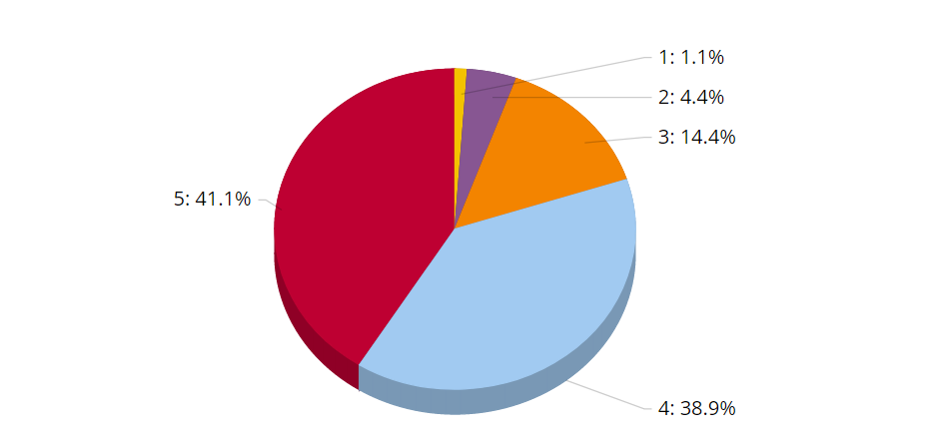

Fig 1. Hasil Survey User SIAP PKL
Note: All the tables and figures must be mentioned in the text.

- Conclusion
Conclusion is written using font Book Antiqua Size 11 dan Spasi 1.0.

Acknowledgment
The acknowledgment is written here. It is written using font Book Antiqua Size 11 dan Spasi 1.0.

References
References should be written using reference management such as Mendeley. Form and style of references in this article are 7th APA (American Psychological Association). Only references that is cited in the article are listed in this section.

Exabple:

Pirti, A., & Hosbas, R. G. (2019). Evaluation of some levelling techniques in surveying application. Geodesy and Cartography, 68(2), 361–373. https://doi.org/10.24425/gac.2019.128463
Skeivalas, J., & Dargis, R. (2006). The accuracy of spatial coordinates determined by trilateration method. Geodesy and Cartography (Vilnius), XXXII(4), 92–96.
Weng, Y. H., Sun, F. S., & Grigsby, J. D. (2012). GeoTools: An android phone application in geology. Computers and Geosciences, 44, 24–30. https://doi.org/10.1016/j.cageo.2012.02.027

This work is licensed under a Creative Commons Attribution Non-Commercial 4.0 International License

Please insert or attach the high-resolution figure for the article cover:
(example figure of article cover)
